**PyOrator user guidance**

This guidance applies to the Windows environment only and assumes that PyOrator has already been installed as described in the PyOrator setup guidance.

**Data structure**

The PyOrator installation sets up a hierarchical data structure comprising one or more study areas each of which comprises one or more farms.

**Study areas**

By convention a study area comprises an area of interest name, typically a district followed by a three-letter country code in parenthesis as defined in [ISO 3166-1](https://en.wikipedia.org/wiki/ISO_3166-1_alpha-3)

**Farms**

This study area consists of 5 farms

**The run file**

PyOrator creates Excel run files named as **FarmWthrMgmt.xlsx** and comprising a complete set of farm, weather and management data for a particular farm.

The following sheets are required:

* Signature
* Up to 8 subarea sheets defining the crop management for steady state and forward run periods.
* Farm location
* Weather for steady state and forward run periods.
* Livestock
* Subareas lookup table

comprising irrigation, rotation, area and soil metrics for each of the subareas

**The PyOrator introductory user interface**

**The Farm tab**

**The Crop Management overview tab**

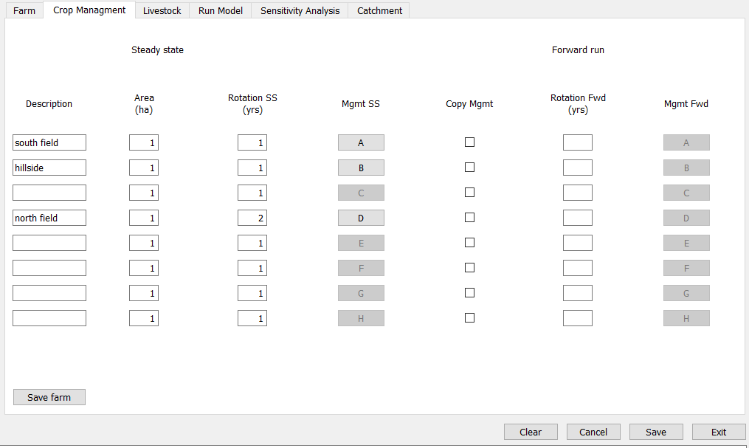

**The Subarea Management tab**

**The Livestock tab**

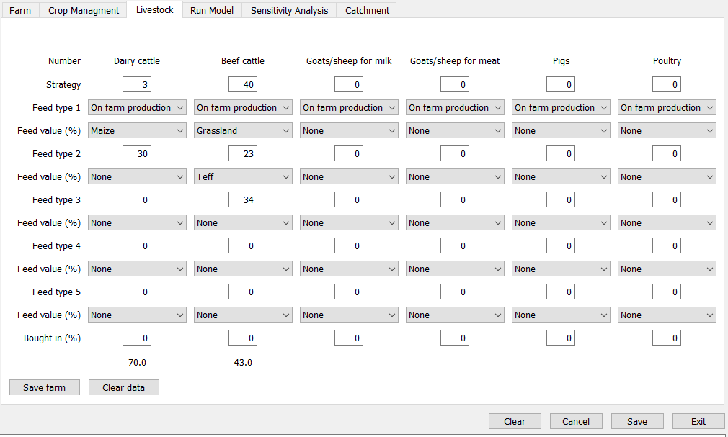

**The Run Model tab**

**The Sensitivity Analysis tab**

